User Manual
Before Playing the Game, you need to understand the rules of Poker.
The Application is designed so that it can be played with only one deck of Cards which contains 52 Cards. The ranking of the cards goes from the Deuce (2) being the lower card to the Ace being the higher ranked Card.
And for this specific application you’ll only win if you get the some pairs or combination of cards. If you don’t get a combination of cards and you press the compare button, a Message will come up saying that “There is no Case for this One”.
These are the possible combinations to win the game:

In case of a draw (eg.: one pair, one pair) the person with the highest one pair will win.

Program:
How to run the Game:
To run the application, it is required to have the JCreator installed on your PC. If you don’t have the JCreator installed, go to the end of this User Manual, and you will find the JCreator Install Guide.

If you already have the JCreator installed on your PC than, you have to follow the following steps:
- Open the JCreator, and click on the open Project button and a new window will show up
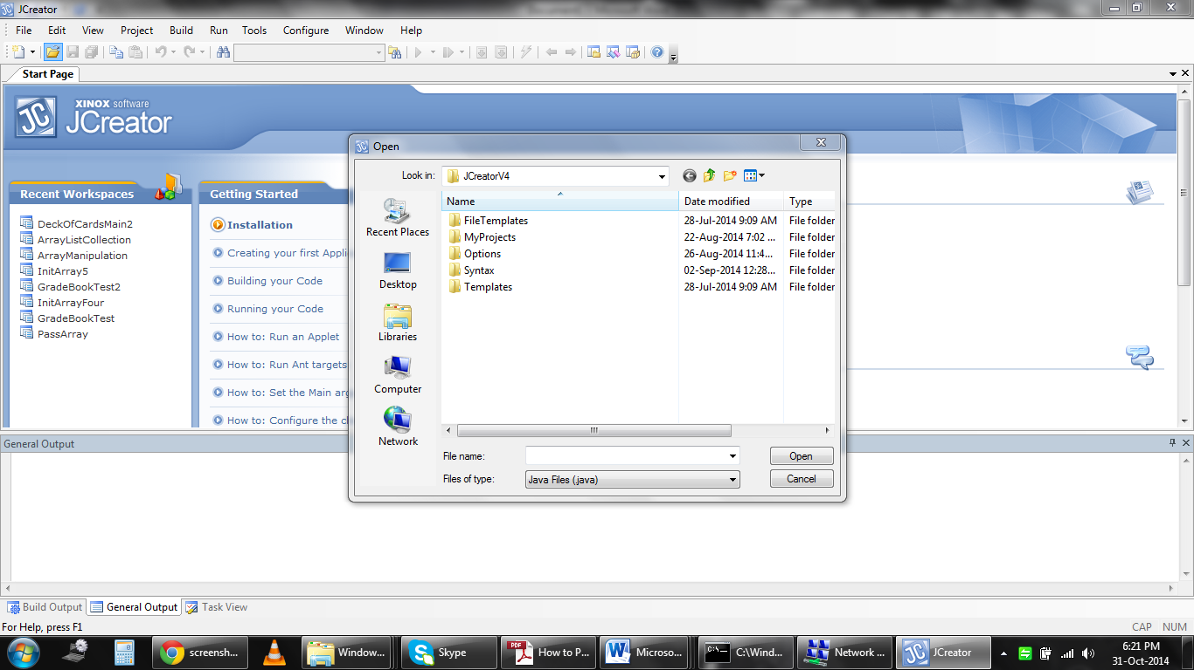
Open Project
- Go to the folder where the Game is (DeckOfCardsMain) and open the “src” folder
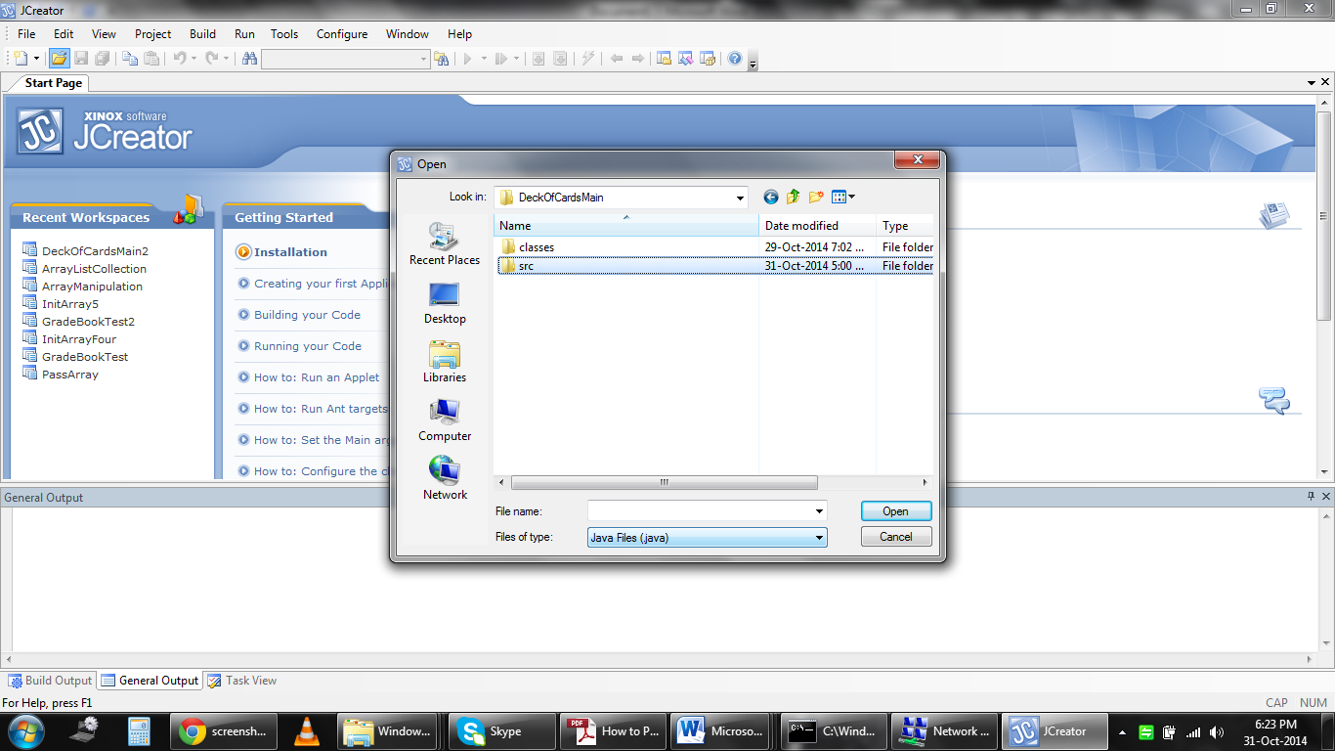

- After Opening the “src” folder, you select all that are inside excluding the folder and then click open.
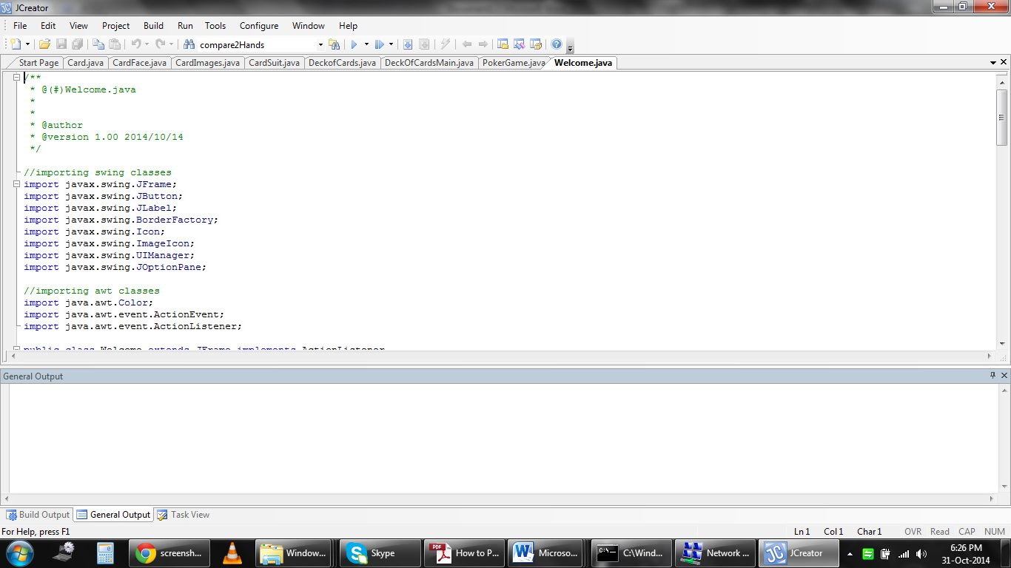
- You should end up with something like this. And then click on DeckOfCardsMain and then build the file.
Build File
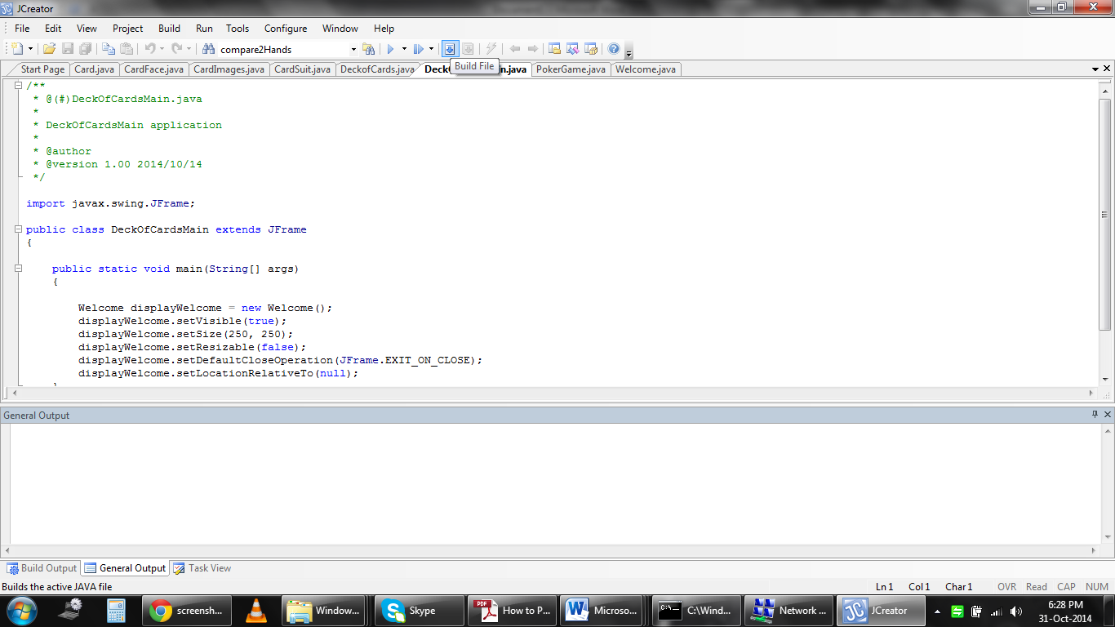
Run the App

DeckOfCardsMain

- After Building the file, you can run the Application by clicking on the Run button.

Running the Game

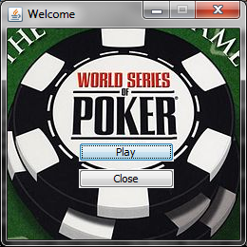
In the beginning you will be given an option were you could choose whether to play or not the Game. If you want to play the game, you just need to click on the Play button else click on exit.

As soon as you click the Play button, you’ll be asked to enter your Name.
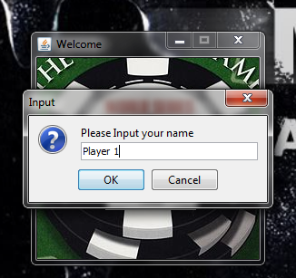

After pressing the Ok button, you’ll be leaded to the Main Window, where you will be playing the Game.
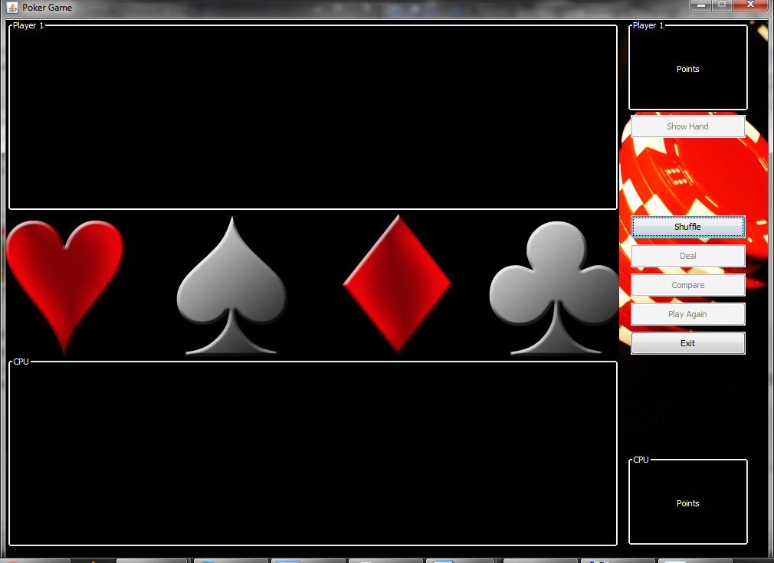
Cards Place
Points Allocation
Buttons
The Shuffle and the Exit buttons are enabled when you start playing, you cannot deal your cards without shuffling. After you have shuffled than the Deal button will be enabled and the shuffle button will be disabled because you will only be able to shuffle once.
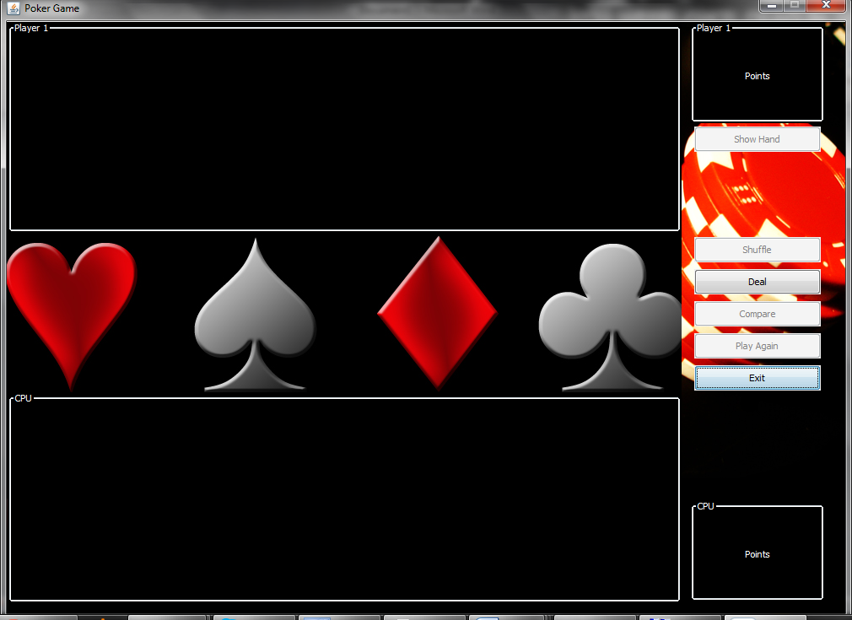
Deal button is Enabled

After Dealing the Cards, The cards will be distributed, and will only be shown the back of the cards.
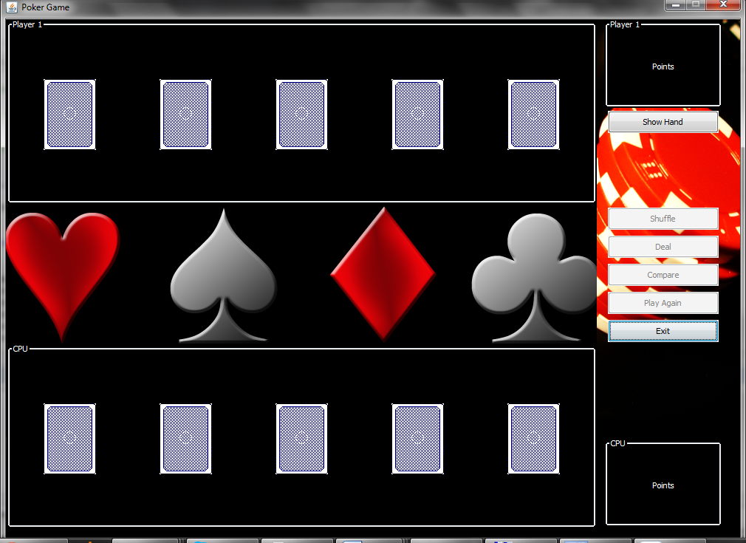
After Dealing the Cards as you can see above, You won’t be able to compare because you the Player 1 hand wasn’t shown. Therefore you need to click on the show hand button and only than the compare button will be enabled.
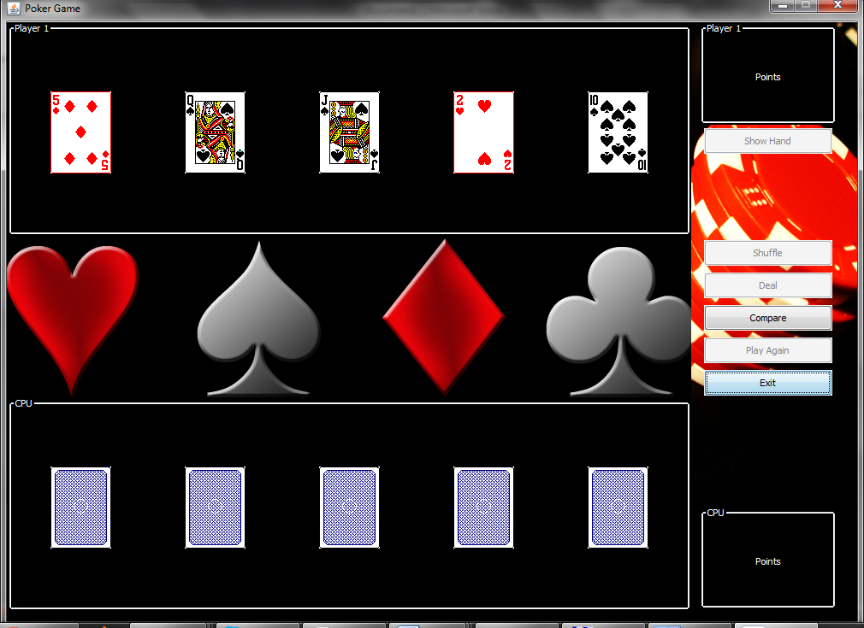

As soon as you click the compare button, the result will be displayed. But as we explained before, you’ll only win if you get the combination for the cards. After comparing, the Play Again button will be enabled and you can choose to play again or not.
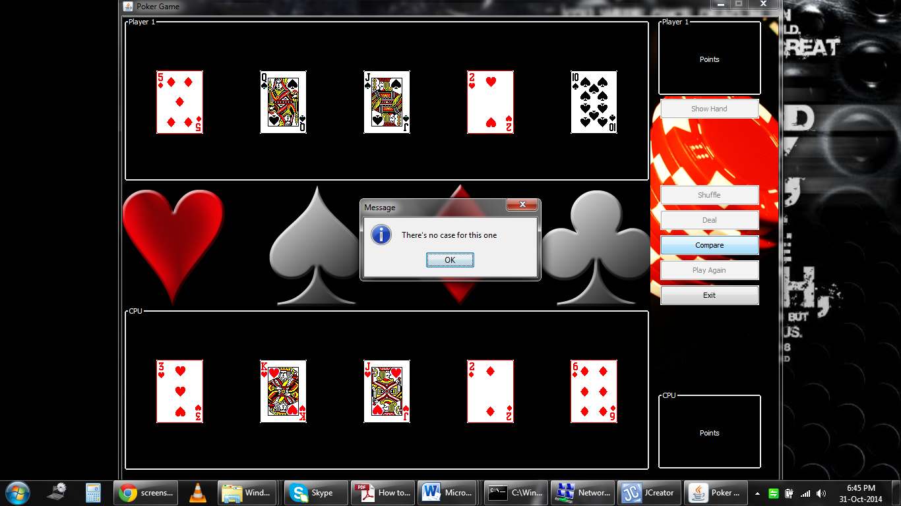

JCreator Installation Setup Guide

Step 1:
Download the non-commercial version of JCreator (JCreator LE Version) from the website:
http://www.jcreator.org/download.htm

Step 2:
Click on the downloaded executable file to start the installation process. A User Settings screen will appear.
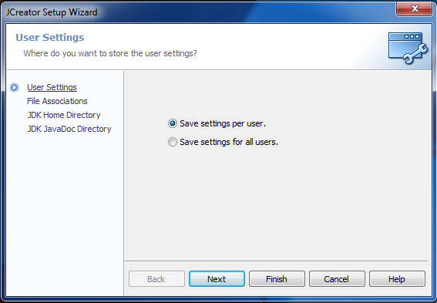
Choose the user settings that you prefer and click on Next to continue the installation process.
Step 3:
A File Associations screen will appear. Click on Next to accept all the file associations shown.

Step 4:

The setup wizard will then ask you to enter the JDK home directory. This is the home directory where the Java SE Development Kit was previously installed. The setup wizard will usually display the directory of the Java SE Development Kit if it was able to locate it on its own. However, you can click on Browse to locate the path of the JDK home directory for the setup wizard:

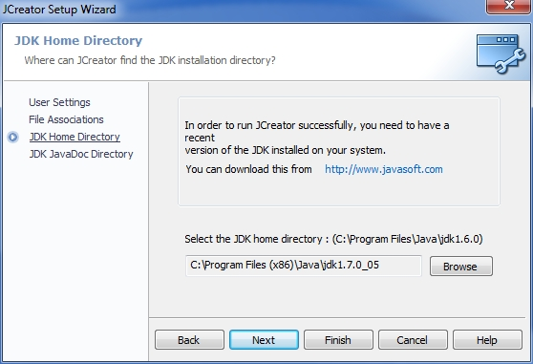

A File Explorer window will open, allowing you to browse to the location of the previously installed JDK. Select the JDK home directory then click OK.
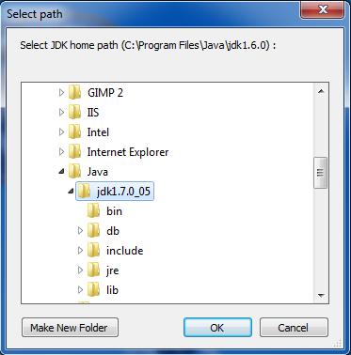

Step 5 (Optional):
The setup wizard will then ask for the location of the Java API documentation. If you have installed the Java documentation, click on Browse to locate the path of the Java documentation directory for the setup wizard:
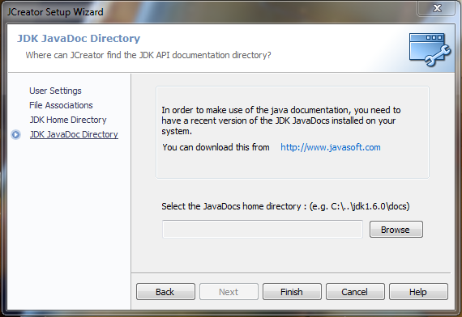

A File Explorer window will open, allowing you to browse to the location of the previously installed Java API documentation. Select the docs folder then click OK.
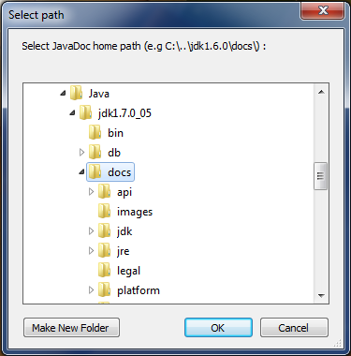

Step 6:
After clicking on the Finish button, the setup process will be completed and JCreator LE will launch.

